ISSA MEDICAL
Main Site: Issa @ Deepdale
Branch Site: Issa @ Fulwood
Associated Practice: St Werburgh’s (Chester)

Date of Review (Version): | Next Review Date: | Edited by: | Approved by: | Comments:
10.05.2023 | 10.05.2024 | Stephanie Hughes | Stephanie Hughes
07.03.2024 | 07.03.2025 | S. Nixon | S. Nixon | Updated as per Practice Index
21.06.24 | 21.05.25 | S. Nixon | N. Green | Updated to include body cameras at Deepdale
14.8.24 | 14.8.25 | S. Nixon | Ann-Marie Donaldson Nixon | Updated as per Practice Index
26.09.2024 | 26.09.2025 | S. Nixon | S. Nixon | Updated as per Practice Index
10.02.2025 | 09.02.2026 |  | B. Vernon | Updated to include St WBs
19.6.25 | 19.6.26 | A M Donaldson Nixon | A M Donaldson Nixon | Updated as per Practice Index

DEALING WITH UNREASONABLE,
VIOLENT & AGGRESSIVE PATIENTS POLICY

1 Introduction

Policy statement

The purpose of this document is to provide guidance to staff at this organisation on how to manage unreasonable, violent and abusive patients in the workplace in line with extant legislation. This organisation has a zero-tolerance policy towards violent, threatening or abusive behaviour towards staff, patients or visitors.

It is the responsibility of all staff to ensure that they recognise, respond to and take the necessary action when dealing with any patient who is behaving in a violent, threatening or abusive manner towards colleagues, contractors or patients. It remains a management responsibility to ensure that all staff have undertaken the necessary training to be able to respond appropriately.

The HSE advises that healthcare workers are four times more likely to experience violence at work than in other vocations. Therefore, effective risk assessment and incident reporting is essential to support the organisation in the appropriate management of offenders, thereby reducing risk to staff, visitors and service users.

Legislation to support this subject and further reading can be sought from Annex A.

Status

The organisation aims to design and implement policies and procedures that meet the diverse needs of our service and workforce, ensuring that none are placed at a disadvantage over others, in accordance with the Equality Act 2010. Consideration has been given to the impact this policy might have regarding the individual protected characteristics of those to whom it applies.

This document and any procedures contained within it are non-contractual and may be modified or withdrawn at any time. Furthermore, this document applies to all employees of the organisation and other individuals performing functions in relation to the organisation, such as agency workers, locums and contractors.

Identifying Challenging Behaviour

Unreasonable behaviour

There are many reasons why a patient’s behaviour may become unreasonable, including:

- Substance misuse
- If they are scared, anxious or distressed
- If they are frustrated, unwell or in pain

All staff may experience patients who are:

- Demanding
- Unwilling to listen
- Uncooperative

There are several factors associated with difficult and challenging interactions with patients, such as a lack of resources, waiting times and interruptions during consultations. For these reasons, the ‘demanding’ or ‘difficult’ patient can potentially consume a large amount of the clinician’s and manager’s time.

It should be noted that unreasonable behaviour may be directed at patients and visitors in addition to staff. A standardised approach is to be adopted to manage any episode of poor behaviour.
In order for the practice to maintain good relations with their patients, St Werburgh’s asks all new patients to read and sign a behaviour agreement as part of the registration process.

Inappropriate behaviour

Inappropriate behaviour is defined as being unacceptable if:

- It is unwanted by the recipient

- It has the purpose or effect of violating the recipient’s dignity and/or creating an intimidating, hostile, degrading, humiliating or offensive environment

Inappropriate behaviour does not have to be face-to-face and may take other forms including written, telephone or e-mail communications or through social media. This is covered in the Intranet & social media Acceptable Use Policy.

What constitutes inappropriate or unreasonable behaviour could be viewed as a subjective matter. Therefore, to ensure objectivity and prior to any further actions being taken, incidents of inappropriate behaviour will be discussed with a member of the senior management team.

Any person, be they staff, visitor or service user, who encounters unreasonable behaviour will be fully supported by senior management.

Violent or abusive behaviour

It is acknowledged that a small minority of patients may become abusive or violent towards staff making it difficult for the healthcare team to provide services. This organisation has a zero tolerance towards such behaviour and is committed to reducing the risk to staff and other patients resulting from such behaviour. The HSE provides a definition of violence in the workplace in its guidance titled How employers can protect workers from violence and aggression at work

While for staff, the Assaults on Emergency Workers (Offences) Act 2018 details the legalisation that supports those who work in general practice, Section 3 (1) (j) (ii) defines an emergency worker. Should violent or abusive behaviour be directed towards a patient or visitor, then ordinarily further action will be taken, including reporting the incident to the police as appropriate.

2.4 CLASSIFICATIONS

Further details to support classifications of inappropriate, violent, abusive and assault can be found at Annex B.

Managing unreasonable and inappropriate behaviour

Nice guidance

All staff are to adhere to NICE Clinical Guidance 138 which explains that patients value healthcare professionals acknowledging their individuality and, by tailoring healthcare services for each patient, this can enhance continuity of care and build positive relationships, thereby reducing the risk of unreasonable and/or inappropriate behaviour.

3.2 PROCESS TO MANAGE UNREASONABLE AND INAPPROPRIATE BEHAVIOUR

The stepped approach to managing challenging behaviour can be found at Annex C.

4 Managing violent, abusive or threatening behaviour

4.1 PREVENTION

The Violence prevention and reduction standard (version 2) primarily focuses on secondary care organisations. However, as these standards focus on best practice, this organisation will aim to implement any recommendations, where practicable, to support a safe and secure working environment for employees.

This organisation will also adhere to the guidance detailed in the BMA’s Preventing and reducing violence towards staff, as well as the HSE’s workplace violence guidance.

Do’s and don’ts when confronted by violence:

DO | DO NOT
Recognise your own feelings | Meet anger with anger
Use calming body language | Raise your voice, point or stare
Be prepared to apologise if necessary | Attempt or appear to lecture them
Assert yourself appropriately | Threaten any intervention unless you are prepared to act upon it
Allow people to explain themselves | Make people feel trapped or concerned

An example infographic summarising violence prevention measures titled How staff can deal with aggression and/or violent behaviour can be found below.

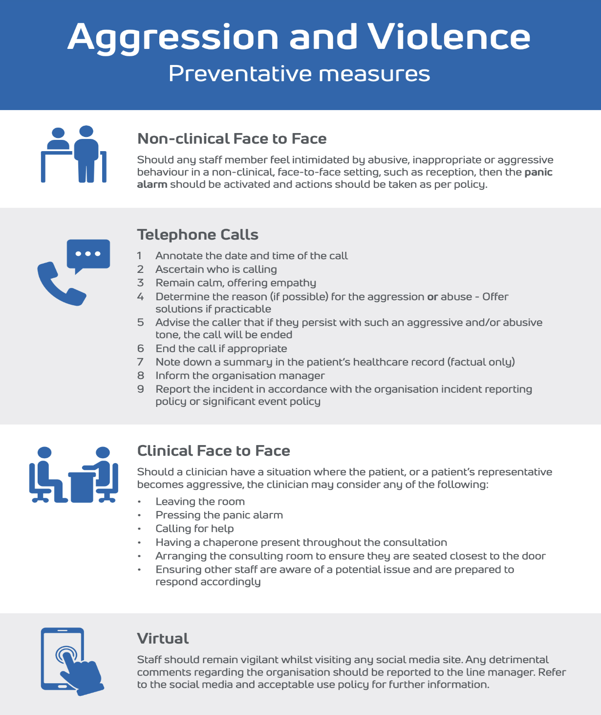

4.2 PROCESS TO MANAGE VIOLENT, ABUSIVE OR THREATENING BEHAVIOUR

The organisation does not expect any staff member, patient or visitor to tolerate any form of behaviour that could be considered violent, abusive or threatening or that becomes so frequent it makes it more difficult for the organisation to undertake its work. Action will be taken to manage this type of behaviour whenever it occurs, including inappropriate behaviour on social media.

Should the episode of behaviour be significant, warranting an immediate application to remove the patient from the practice list, the steps within the Removal of Patients Policy are to be followed. The BMA document titled Removing patients from your practice list should also be consulted.

It should be noted that the same standards of zero tolerance also apply should patients who demonstrate violence towards other patients or visitors.

Should an incident warrant a warning, then the process at Annex C can be followed.

Guidance on the removal of a patient process is at Annex D.

5 Raising the alarm

5.1 USE AND ACTIVATION OF AN ALARM

The organisation has an on-screen alarm button on EMIS which enables staff to respond should the alarm be pressed.

Staff will be advised during their induction of the alarm(s) to be used for a clinical emergency and when they feel threatened by a situation involving:

- Verbal or physical disruption
- Verbal aggression
- Physical aggression or the threat of physical violence or mental distress
- Physical violence
- The receipt of a bomb threat or coming across a suspicious package.
- Any consideration of terrorist activity. In this situation, the Dynamic Lock Down Procedure is to be initiated (please see below.)

All staff who work during periods of low manning within the building can consult the organisation’s Lone Working Policy.

Should staff at any point feel threatened or sense that the situation may lead to an incident, they are to activate the alarm.

5.2 RESPONSE PROCEDURE

Upon activation of the alarm or upon seeing the clinical system generated alarm then:

- All available staff should respond immediately
- Staff will go to the incident location, proceeding with caution
- The first member of staff is to knock and then enter the room
- The second is to remain in the doorway, ready to summon additional support if necessary

The specific nature of the incident will determine if:

- Additional staff are required for support
- The police are required to attend and take any subsequent action
- The situation can be resolved by the clinician with support from a staff member

Staff should always try to minimise the risk of harm to themselves and others. In the first instance, a member of the staff should ask the perpetrator to stop behaving in an unacceptable way. Sometimes a calm and quiet approach will be all that is required. Staff should not, in any circumstances, escalate or mirror the patient’s behaviour.

Should the person not stop their behaviour, then a nominated member of staff should be asked to attend and an overview of the situation should be calmly detailed, preferably within hearing of the perpetrator. Should the person be acting in an unlawful manner, causes damage or assaults another person, then the police should be called immediately.

Should it prove necessary to remove the person from the organisation then the police should be asked to attend. Staff should never attempt to manhandle the person from the premises.

5.3 POLICE ASSISTANCE

The police should be called in instances where physical assault is likely or where weapons or drugs have been identified.

The Practice Manager is required to notify the CQC of an incident that is reported to or investigated by the police as detailed within CQC GP Mythbuster 21: Statutory notifications to CQC.

5.4 BOMB THREAT AND SUSPICIOUS PACKAGE

In the event of a bomb threat or a suspected package and the information relates to a patient area, then the message is to be calmly discussed and subsequent evacuation procedures are to be commenced.

5.5 Dynamic lockdown procedure

A lockdown is a procedure used when there is an immediate threat to the building and its occupants.

Should there be any hint or if a credible warning or evidence of any ongoing terrorist activity, then staff must comply with the Stay Safe principles outlined below.

Stay Safe principles are:

Run

- Escape if you can
- Consider the safest options
- If there is a safe route then RUN
- Can you get there without exposing yourself to greater danger?
- Insist others leave with you
- Leave belongings behind

Hide

- If you cannot RUN then HIDE
- Find cover from gunfire
- If you can see the attacker(s), they may be able to see you
- Cover from view does not mean you are safe, bullets go through glass, brick, wood and metal
- Find cover from gunfire, e.g., substantial brickwork/heavy reinforced walls
- Be aware of your exits
- Try not to get trapped
- Be quiet, silence your phone
- Lock/barricade yourself in
- Move away from the door

Tell

- Call 999 – what do the police need to know?
- Location – where are the suspects?
- Direction – where did you last see the suspects?
- Descriptions – describe the attacker(s), numbers, features, clothing, weapons etc.
- Further information – casualties, types of injury, building information, entrances, exits, hostages etc.
- Stop other people from entering the building if it is safe to do so

In the event of a lockdown being required at both Issa sites, shutters will be closed, and doors locked where possible. Most doors have fobbed access. At St Werburgh’s the front door will be locked as well as any unfobbed doors.

5.7 DEACTIVATION INSTRUCTIONS

Alarm types | Descriptions/locations | Deactivation instructions
Static – intruder system | Staff entrance  Main foyer entrance  (at both sites) and front door at St Werburgh’s | Press fob against the alarm
EMIS screen software (button) | All screens when logged on | Alarm is deactivated once assistance has been acknowledged

6 Removal of the Patient

6.1 GUIDANCE

While it is acknowledged that organisations are permitted to remove patients in appropriate circumstances as detailed within GMC guidance titled Ending your professional relationship with a patient and BMA guidance titled Removing patient from your practice list guidance, removal should never be based on the grounds of race, gender, social class, age, religion, sexual orientation, appearance, disability or medical conditions.

Actions available to the organisation can be sought at Annex D.

7 Reporting of incidents

7.1 INTERNAL REPORTING

All incidents are to be reported to the Practice Manager and SEA leads at the earliest opportunity. They will ensure that any subsequent reporting action is taken while supporting staff in the completion of the significant event report.

7.2 CLINICAL RECORD

A factual entry is to be made in the patient’s healthcare record detailing exactly what occurred; the record should include timings, the build-up to the incident and details of staff members and witnesses present.

Further information can be sought at Annex C.

7.3 SIGNIFICANT EVENTS

In addition to recording the information in the patient’s healthcare record, the staff member dealing with the patient is to complete a significant event form on TeamNet.

Further advice on significant events including understanding and acting on any lessons that should be learnt following any incident can be found in the Significant Event Protocol and Significant Event & Incident Policy.

8 Risk assessment

8.1 REQUIREMENT

The organisation’s Health, Safety and Risk Management Handbook provides comprehensive guidance on managing specific risks and should be read in conjunction with the HSE’s Violence and aggression at work guidance. A template for conducting a risk assessment can be found at Annex E.

9 Effects on staff and patients

9.1 SUPPORTING THE TEAM

Any staff member who has been subjected to inappropriate behaviour will be supported. Staff who experience incidents of violence, aggression or assault may experience subsequent after-effects that may require support from the team or external resources.

9.2 DEBRIEFING THE TEAM

Clinical debriefing refers to learning conversations that occur soon after an event and involve those who took part. This is also known as ‘hot debriefing’ or ‘proximal debriefing’.

The aims of debriefing are to:

- Discuss how, why and what occurred
- Promote learning and reflection for individuals and teams
- Identify opportunities for improvements in workflows, processes and systems
- Identify any key points and lessons learnt
- Ensure that the health and wellbeing of staff members are not adversely affected

The management team will support all staff members following any incident, no matter how minor it may seem. Both positive and negative points should be considered that can support organisation-level training in the support of any future events.

9.3 SUPPORTING PATIENTS

Should any patient be subjected to violent, abusive or aggressive behaviour then, as for staff members, they may need support, and this may be from a clinical or non-clinical member of the team. It is likely that the minimum would be to have a debriefing about the incident although in many cases the police would need to be involved. External support may also be required.

Annex A – Legislation and further reading

The following legislation supports this policy:

- Health and Safety at Work Act 1974
- Management of Health and Safety at Work Regulations 1999
- Reporting of Injuries, Diseases and Dangerous Occurrences Regulations
2013 (RIDDOR)
- Assaults on Emergency Workers (Offences) Act 2018
- Safety Representatives and Safety Committees Regulations 1977
- Health and Safety (Consultation with Employees) Regulations 1996

Further reading can be sought from:

BMA | Preventing and reducing violence towards staff  At the sharp end: handling patient violence  On the receiving end: violence aimed at doctors
GMC | Ending the professional relationship with a patient
HSE | Violence and aggression at work  Violence at work
LGBTQ+ | For managing inclusive behaviour visit Gender Identity Toolkit for General Practice on TeamNet
MDU | Dealing with challenging patients
NHS E | Violence prevention and safety

Annex B – Classifications

Unreasonable and inappropriate behaviour

Some examples of inappropriate behaviour that is deemed to be unreasonable includes, but are not limited to the following:

- Aggressive or abusive behaviour, such as shouting or personal insults, in person or via social media

- Discrimination or harassment when related to a protected characteristic under the Equality Act 2010

- Unwanted physical contact

- Spreading malicious rumours or gossip or insulting someone

- Stalking

- Offensive comments/jokes or body language

- Persistent and unreasonable criticism

- Unreasonable demands and impossible requests

- Coercion, such as pressure to subscribe to a particular political or religious belief

Violent or abusive behaviour
- Any incident in which “an employee is abused, threatened or assaulted in circumstances relating to their work” (HSE 1996)

- The intentional application of force to the person of another, without lawful justification, resulting in physical injury or personal discomfort

- The use of inappropriate or discriminatory words or behaviour causing distress and/or constituting harassment

- Behaviour that is hostile, destructive and/or violent

Assault

- Physical assault is the intentional application of force to the person of another, without lawful justification, resulting in physical injury or personal discomfort

- Non-physical assault is deemed to be the use of inappropriate or discriminatory words or behaviour causing distress and/or constituting harassment

Annex C – Process to manage poor behaviour

The following process is to be taken to support poor behaviour at this organisation:

- Discuss

When interactions become challenging, staff are advised to discuss these more difficult consultations/conversations with their peer groups, seeking guidance when applicable and assurance that they have handled the situation in the most appropriate manner.

- Record keeping

To support any decisions made on behalf of the organisation, members of staff who experience patients who are challenging and make unreasonable demands must record the events as accurately as possible.

Any record should be strictly factual.

The Medical Protection Society states in its guidance that if a patient’s behaviour is likely to be relevant to their health, then it should be documented factually within the medical record. However, if incidents arise outside the context of a consultation, say in reception, or when telephoning, it should be considered as to whether the behaviour should be documented in the medical records or not.

There can be circumstances in which it would be more appropriate to record any incidents with a patient in a separate folder. Any information about a patient stored outside the records would still be required to be disclosed on request by the patient under data protection legislation.

Any entry made in the patient’s healthcare record should detail exactly what happened, including timings, the build-up to the incident and those staff members present. Care should be taken not to record opinions or perceptions that may prejudice others in the event of the patient seeking to register elsewhere for any reason.

- Speaking to the patient

In the first instance, and to maintain an effective relationship with the patient, it is recommended that the patient be spoken to by the clinician who is treating them. The clinician can provide reassurance to the patient about their condition and address any concerns.

A recommended approach to help in such scenarios is to verbalise the difficulty, such as:

“We both have very different views about how your symptoms should be investigated and that is causing some difficulty between us. Do you agree?”

Verbalising such difficulties may enhance the level of trust between the clinician and the patient, enabling feasible options for care and treatment to be discussed.

Clinicians will not be forced into giving a diagnosis or treatment if they are uncertain. This should be explained to the patient while also explaining that it is in his or her interest that the most appropriate solution be found and that it can take time to confirm a diagnosis.

- Writing to the patient

Should the patient’s behaviour remain unreasonable despite the above actions having been taken, the matter will be referred to the Practice Manager who will then write to the patient.

- Behaviour agreement

If a patient continues to act in an unreasonable manner despite being issued a letter about their behaviour, the organisation may establish a ‘behaviour agreement’ that allows boundaries to be detailed and agreed to.

This agreement should be retained in the patient’s healthcare record and reference will be made to the agreement should the patient’s behaviour deteriorate once again.

- Removal from the organisation

Should the patient be non-compliant as per the behaviour agreement in a manner that contravenes the agreement then consideration should be given to removing the patient from the organisation list.

This final stage should never be taken lightly and will be agreed by the management team. The patient will be advised that the doctor/patient relationship has deteriorated to such a degree that there is no longer any trust between the parties and the relationship is not viable.

The patient will be asked to register at another organisation. Further guidance can be sought within the GMC’s ethical guidance for doctors on ending the professional relationship with a patient.

Annex D – Available actions to remove a patient

Actions available to the organisation

- Warnings

- For unacceptable, threatening or abusive behaviour, the patient will be warned that the organisation is considering removing them from its list

- A letter will be sent which advises that, should there be any further incidents of inappropriate behaviour, they will be removed and requested to register elsewhere

- Records of all warnings should be retained and, if a warning has been given in the preceding 12 months, there are grounds for requesting removal

- When behaviour is an issue, this organisation will do all that it can to ensure that this is rectified. In these instances, a behaviour agreement can be raised.

- Removal

Prior to seeking formal approval to remove a patient from the organisation list, the following is to be adhered to:

- Judgement is to be exercised in determining whether a patient’s violent behaviour is a result of their medical condition. When doubt exists, further guidance should be sought from the Local Medical Committee and/or medico-defence representatives

- There must always be a justifiable reason(s) for seeking approval to remove the patient from the organisation list

- For instances when there is deemed to be a breakdown of doctor-patient relationship or should there be any repeat of the inappropriate behaviour within a 12-month period since the previous warning, then the patient can be removed. The process to is detailed below:

- Should a patient be violent, e.g., when the police are involved, then in these cases the patient will be removed immediately. It should be noted that if the removal is on the grounds of violence or threatened violence, the police must always be informed, and a police incident number obtained.

- If it is for a clinical reason as to why the patient’s behaviour was deemed inappropriate, consider changing the patient’s GP internally

When removal has been found to be justified, the organisation will:

- Write to the patient explaining why they are to be removed from the organisation list (only if this is deemed appropriate).

- Record the decision, attaching the letter(s) to the patient’s healthcare record

- Determine the most appropriate arrangements for continuing the patient’s care and facilitate the timely transfer of the patient’s healthcare record

Actions by PCSE (8-day removal)

Should there be a requirement to remove the patient following their unreasonable behaviour and a warning has already been provided to them in the preceding 12-months period, then PCSE will remove patients eight days after they receive the request.

However, if patients require treatment at intervals of less than seven days, the organisation is obliged to provide such treatments until the condition of the patient improves. In such instances, removal will occur on the eighth day after treatment ceases or until the patient is accepted by another organisation.

To request an 8-day removal, PCSE are to be informed via the Patients Removal Form as detailed upon their Patients removal webpage or the paper form can be sent to pcse.patientremovals@nhs.net.

Actions by PCSE (immediate removal)

In instances when patients are violent, abusive, threatening or have displayed signs of generally unacceptable behaviour, or where there are concerns for staff and other patients’ safety, the police are to be notified. The organisation can have the patient immediately removed within 24 hours once they have notified PCSE by either telephone or email.

To request immediate removal of a patient and for further instructions, refer to the PCSE guidance.

The organisation must ensure that the reason(s) for removal is recorded in the patient’s healthcare record, along with any supporting documentation such as previous warnings or information leading up to the removal of the patient.
Annex E – Risk Assessment and Control Form

Brief task description: Interacting with violent or aggressive patients

Organisation name: Issa Medical and associated practices

Date completed: 21/06/24

Risk assessment title | Unreasonable, violent and abusive patients | Date of assessment | 21/06/24
Assessment conducted by | S Nixon (Ops Mgr) | Date of next review | 21/06/25
Contributors | Ann-Marie Donaldson Nixon (QA Manager) | Risk reference | 06/24

What are the potential hazards? | Who is at risk of being harmed and how? | What are you already doing to control the risks? | Risk rating | Additional control measures required | To be implemented: by who, by when? | Residual risk
Patients may be aggressive /violent due to illness or mental health issues or may be known to have a history of violence/ aggression. | Staff, patients, contractors, visitors could be verbally abused or physically abused resulting in psychological or physical injuries, potentially serious injuries. | There is a robust policy in place.  All staff have received training in dealing with abusive, aggressive and violent patients.  All staff have received de-escalation training.  Alerts are recorded on the clinical system for this cohort of patients.  EMIC panic alarm available.  Clinical staff know how to set up their consultation rooms to ensure they have an escape route.  Information is available in waiting areas and on the website promoting zero tolerance. | 9 | Ensure the policy is reviewed annually  Monitor training compliance  Monitor training compliance  Regularly review and update alerts as required  Run an exercise to test response to panic alarms  Review and update information as and when required | S. Nixon – ongoing  D.Robinson – ongoing  Ops Mgrs – ongoing  All staff – ongoing  All staff – completed mid July  K. Berry – ongoing | 6

 |  | Likelihood
 |  | 1  Rare | 2  Unlikely | 3  Possible | 4  Likely | 5  Almost certain
Consequence | 5  Catastrophic | 5  Moderate | 10  High | 15  Extreme | 20  Extreme | 25  Extreme
Consequence | 4  Major | 4  Moderate | 8  High | 12  High | 16  Extreme | 20  Extreme
Consequence | 3  Moderate | 3  Low | 6  Moderate | 9  High | 12  High | 15  Extreme
Consequence | 2  Minor | 2  Low | 4  Moderate | 6  Moderate | 8  High | 10  High
Consequence | 1  Negligible | 1  Low | 2  Low | 3  Low | 4  Moderate | 6  Moderate

